CFLeads EMAN Policy Training Packet

Five-Step Policy Change Model for Community Foundations

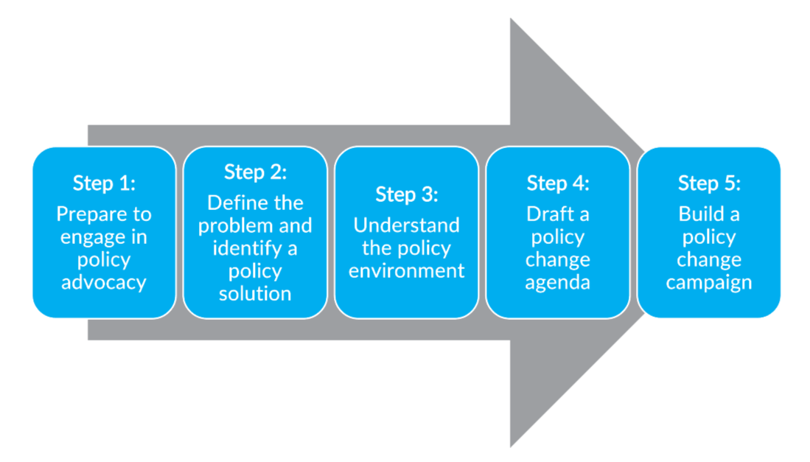

Policy Advocacy Engagement Checklist

Step 1: Prepare to Engage in Policy Advocacy
- Has your community foundation completed an internal policy change capacities and priorities assessment?
- Does your foundation have an established policy advocacy decisionmaking process?
- Does your foundation have a process to assess the fit of policy advocacy activities (i.e., their alignment with the foundation’s mission and vision)?
- Does your staff/board/foundation leadership understand your policy change capacities and internal policies?
- Has your board of directors authorized the specific policy advocacy being considered?
- Does your foundation have the internal resources to address or engage in policy?
Step 2: Define the Problem and Identify a Policy Solution
- Has your community foundation or its partners collected and translated available data to clearly understand the policy problem?
- Does your foundation clearly understand who is most impacted by the policy problem?
- Has your foundation conducted community engagement, engaged your community advisory board, or consulted recent community engagement reports to learn about the lived experience of people who have encountered the problem of interest?
- Have you identified a clear policy solution that has evidence to support its efficacy? If the solution is novel, have you collected evidence to suggest its potential?
- If you have identified a policy that you would like to support, have you reflected on who will not be served by this policy? If they are a key population for whom you are hoping to create better outcomes, how might you support other systems changes to accompany the policy change?
Step 3: Understand the Policy Environment
- Does your community foundation have a strong understanding of the local and national champions and opponents of your selected policy change?
- Has your foundation completed a policy ecosystem map?
- Do you know who your allies are and what actions they have already taken regarding this policy problem?
- Have you reflected on your relationship with your allies? How will they view your foundation playing a role in this policy change?
Step 4: Draft a Policy Change Agenda
- Has your community foundation created an audience-tailored rationale for action to advocate for this policy change?
- Is your case for why your foundation should get involved and the role you should play clear and specific?
- Have you brought your board along with you for the policy change you have selected and the role you intend to play in the policy change process?
Step 5: Build a Policy Change Campaign
- Has your community foundation created an internal tactical document that explains how it will implement your policy change agenda?
- Is the plan realistic and detailed enough to facilitate action?
- Do you have the staffing and sign-off from your leadership and board to execute your policy change campaign?

Community Foundation Roles in Policy Change

Adapted with permission from BoardSource.
Use table B.1 to assess your community foundation’s policy change capacity. Which roles does your foundation perform well? Place a checkmark in each row based on where you believe your foundation falls.
Table B.1
Community Foundation Policy Change Capacity Assessment
 | Our foundation does this, and we are confident in how we play this role | Our foundation does this, but we would love to learn more about this role | Our foundation does not do this, but we would love to learn more about  this role | Our foundation does not do this, and we do not want to or cannot play  this role
CONVENER:
Bring government, nonprofit, foundation, and business together to address issues of importance.

EDUCATOR:
Raise awareness of policy matters with the general public, media, and policymakers.

CAPACITY BUILDER:
Provide training for foundation staff, board members, grantees on policy advocacy, working in coalitions, lobbying laws, and effective communications with policymakers.

FUNDER:
Fund advocacy and legal lobbying activities and coordinate with other funders.

DONOR ENGAGEMENT:
Engage donors or board members to lend their voice to advocacy.

RESEARCHER:
Publish reports that educate policymakers, the general public, and media on specific policy issues.

DEFENDER:
Engage with and support groups that work to protect the interests of all nonprofits and defend against state and federal policy threats on core issues (e.g., regulation, tax policy, independent decisionmaking), including filing lawsuits or writing amicus briefs.

PARTNER:
Join coalitions that are working toward systems changes at the local, state, and/or federal levels.

Source: Adapted with permission from BoardSource. For more information on BoardSource, visit www.boardsource.org or call 202-349-2500. Content may not be reproduced without written permission from BoardSource.

Writing Your Rationale for Action

Fill out boxes 1-6 to draft notes about the different components needed in your Rationale for Action. Once you have filled out all required sections, you can begin to compose your full rationale.

- What is the problem that needs to be addressed in your community?

- What are the relevant root causes of the problem?

- What data and evidence do you have about the scope of the problem?

- Why have previous efforts to address this problem not worked?

- Why is now the right time to act?

- Why do we (the community foundation) need to get involved?

- What would we expect to see if we adequately addressed the problem?

- How did we identify this particular policy as the one to advocate for?

- What evidence do we have that this policy will be effective in addressing the problem?

- Who might not be served by this policy?

Policy Ecosystem Mapping

Ideas: paradigms, core beliefs, monopolies of understanding
Institutions: the formal and written, or informal and unwritten rules of policymaking
Networks: the relationships between policymakers and influencers
Context and Events: changes in socioeconomic factors, or routine/ non-routine events

Policy Change Logic Model

Process Outputs | Process Outcomes | Short-term Policy Outputs (Impacts on Systems and Resources) | Long-term Policy Outcomes (Impacts on People and Communities)

